Raspberry Pi setup

LOTI.05.010 Robotics

Spring semester 2015/16

Practice session 1
The aim of this practice session is to set up the Raspberry Pi platform for use with the Dexter Industries GoPiGo robot kit as well as getting familiar with basic Linux terminal usage principles.
Each of you will be using an SD-card dedicated to you during these practice sessions, so make sure you remember the number of the SD card for the next lab.

Preparing the SD card
Operating system for Raspberry Pi is stored on the micro-SD card. For this course we will be using the Raspbian operating system customised by Dexter Industries. Raspbian OS is the official operating system of the Raspberry Pi and is based on Debian Linux. First step is to get the image. You will need a micro-SD card and a computer with a SD card reader. If you are using your own computer you need to download it:

- Go to download page:
(https://sourceforge.net/projects/dexterindustriesraspbianflavor/)
- Click Download

If you are using practice session computers, ask the instructor before downloading the file, because you have to change the default download location to computer’s HDD. After you have downloading the image you need to unpack it. Then you need to write it to the SD card.

Windows
If you are using Windows, follow the instructions on http://www.dexterindustries.com/howto/install-raspbian-for-robots-image-on-an-sd-card/ and skip the Linux instructions part.

Linux
First you have to know which device is the SD card. Open terminal and run
df -h
You will see all connected storage devices. Then insert the SD-card and run the command again. A new device should appear, in this case it is
/dev/sde1

In Linux the device path has usually following pattern: /dev/sdXY. Here X is a physical device and Y is partition. In this example device /dev/sde has one partition: /dev/sde1. Remember the device, you will need it later.

You can see on possible output on following image.
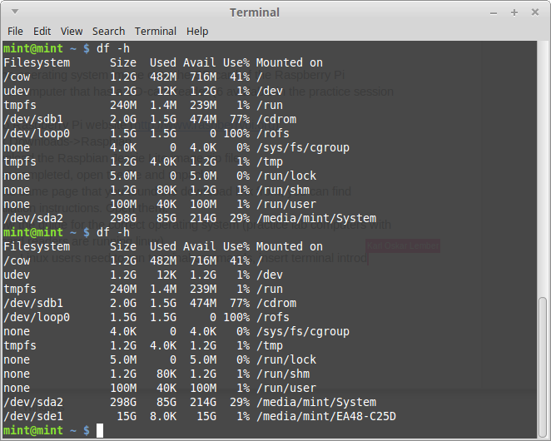
To write the image to SD-card, you need to install dcfldd, to install, run following command in terminal
sudo apt-get install dcfldd
Next you need to unmount the SD-card, otherwise you cannot write the image to it
umount /dev/sde1
Next you need to find the downloaded image file file. Open Computer and there you should see computer’s hard drive. In this case it is System. Click on that and go folder Downloads, there you should see the image file. Click on the icon and you can see the full path to the file.
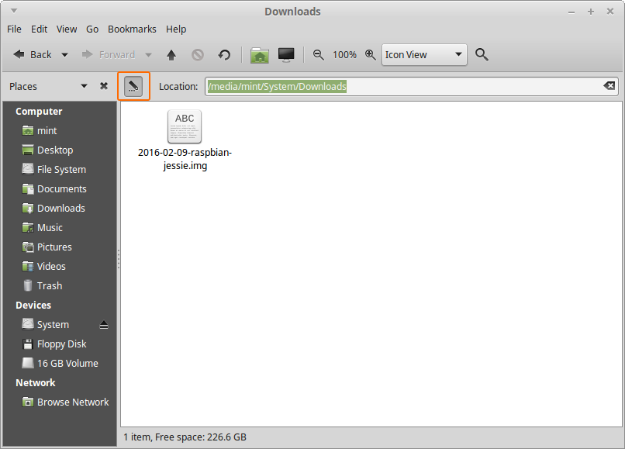
To copy the image to SD-card, insert following command.
sudo dcfldd bs=4M if=/path/to/image/file.img of=/path/to/sd/card
Replace /path/to/image/file.img with what you found in previous point and /path/to/sd/card with path to SD-card.
The command should look something like this
sudo dcfldd bs=4M if=/media/mint/System/Downloads/2016-02-09-raspbian-jessie.img of=/dev/sde

If the writing is finished, the output looks something like this
768 blocks (3072Mb) written.
984+0 records in
984+0 records out

Connecting the cables
The SD-card is now prepared. Remove it from the computer and microSD to SD adapter. Now we can connected devices to the Pi and start it. When working on the Pi, be careful not to give it a static shock (avoid this by grounding yourself on a big piece of metal and not wearing wool clothing) or cause mechanical damage to it.
- Connect mouse, keyboard, monitor cable and SD-card to you Raspberry Pi.
- Connect the power adapter and the Raspberry Pi should turn on.

If you do not see anything on the screen, you will have to switch the monitor input to DVI (if you do not know how to do it, ask the instructors).

Running the Pi
At this point, you should see numbers running on the display or the graphical user interface. Now it’s time to start configuring your Raspbian operating system.

Start by connecting your Pi to the internet. You can use the WiFi network Robotiklubi24, passkey Labor001. You can select the WiFi network from top right corner, click on the icon with computer screens.

Configure the software
Before you start, read the document which introduces the Linux terminal. It can be found here: https://help.ubuntu.com/community/UsingTheTerminal#Commands. It covers the basic commands and different keyboard commands that will make your life a lot easier.

Update to latest software
Open the terminal again and insert
sudo apt-get update && sudo apt-get upgrade
This will update the software packages to the latest version.

Raspi-config
On linux, a lot of work can be done using the text based terminal. Open the terminal by clicking on the display icon in the top left corner of the screen. Into the terminal, enter the command
sudo raspi-config

This will run the Raspberry Pi configuration utility as the root user or superuser. You can use the up and down arrow keys, enter, tab and escape keys to navigate in this utility.

When copying the OS image onto the SD card, you may have noticed that it was only around 4GB large. This means that it takes up about 4GB of space on the SD card as well, but the OS cannot use the rest of the space on the SD card. Luckily, we can expand the file system so we can use that space. Choose the expand filesystem option in raspi-config. After this has been completed, use the Tab button and right arrow key to choose the finish option. Reboot when asked.

Now click on the menu button in the top left corner, go to Preferences->Mouse and Keyboard Settings->Keyboard->Keyboard Layout. Here you can choose the keyboard layout of your choice (lab keyboards mostly have Estonian layout).

Now open the Raspberry configuration utility again. Change the keyboard layout, password and timezone.
- Choose Internationalisation Options → Change Keyboard Layout → Default is ok → Choose your language → Default is ok → Default is ok → Yes → Finish
- Choose Change User Password and add a password to keep your Pi safe. The default password is robots1234, so it can is a quite big security issue if you don’t change it.
- Choose Internationalisation Options->Timezone. Choose the correct Timezone

Select Finish and reboot the Pi.

Last thing to configure is hostname:

Debian based systems use the file /etc/hostname to read the hostname of the computer at boot time and set it up using the init script /etc/init.d/hostname.sh. We can edit the file /etc/hostname and change the hostname and then run: /etc/init.d/hostname.sh start

Enter in terminal:
sudo nano /etc/hostname
Save the file with the hostname you like to set. To do that, delete dex and replace it with something unique. For example firtnamelastname
sudo /etc/init.d/hostname.sh start

Connecting to RaspberryPi over WiFi
The Raspberry Pi can be accessed remotely using SSH. We shall now try this using some other computer. The default username in Raspbian is ‘pi’, Password is the one you configured earlier.

When you have problem connection to your Pi, try setting the hostname again.

Windows
Windows does not have a SSH client by default, so you will have to download one. Putty is one of the most popular programs for this job. You can download it from http://the.earth.li/~sgtatham/putty/latest/x86/putty.exe

Open putty and into Hostname (or IP address) slot enter YOURHOSTNAME.local, where you replace YOURHOSTNAME with your previously configured hostname. Then click open. Enter username (pi) and password when asked.

Linux
Linux usually has ssh client installed. To connect enter command
ssh pi@YOURHOSTNAME.local
Enter password when asked.

Now you can access the terminal program on your Pi from a different computer and run programs that don’t require a graphical user interface.

If you want to run programs with GUI, you can add flag -X to the ssh command.
ssh -X pi@YOURHOSTNAME.local
Then you can run a command, for example
idle-python2.7 &
and a Python IDLE should open up. If you do not use ampersand at the end of the command, you will not be able to enter more commands until you close Python IDLE.

You can read more about it from
http://www.vanemery.com/Linux/XoverSSH/X-over-SSH2.html

When you have established an SSH connection to your Pi, try restarting it remotely with a terminal command.

Remote desktop protocol
Now we will install a method so we can use remote desktop to connect to the Pi and access a graphical user interface (you can install this through ssh as well).
First you need to run the command
sudo apt-get install xrdp
in the terminal to install the xrdp software. This software runs a remote desktop server on the Pi.

Connecting to RDP

Windows
- Open Remote Desktop Connection
- On computer name input YOURHOSTNAME.local, where YOURHOSTNAME is the hostname you previously configured.
- Click connect
- Username is pi and password is what you previously configured
- Click ok
You should now be logged in to your pi

Linux
- Install Remmina: https://github.com/FreeRDP/Remmina/wiki
- Open Remmina
- Create new connection
- Server is YOURHOSTNAME.local
- Protocol is RDP
- Username is pi
- Password is what you previously configured
- Click connect
You should now be logged in to your pi

If everything seems to be working, shut down the Pi, disconnect everything except WiFi and SD card and ask instructors for the robot kit to test, if everything is working.

Additional configuration
You can browse around in raspi-config and change additional settings. As mentioned previously, you will be using this SD card for the rest of the course, so you can customise it as much as you like. Keep in mind, that if you corrupt the installation, you will have to install and configure Raspbian again. If you have your own computer with an SD card reader, you can clone your Raspbian image to it as a backup file.
Windows tutorial: https://www.raspberrypi.org/forums/viewtopic.php?p=239331
Linux tutorial: https://www.raspberrypi.org/documentation/linux/filesystem/backup.md

End of the lab
Shut down the Pi and and disconnect all the cables. Pack everything and return them to instructors. Remember the number of your SD card, you will use it again in the next session.

